Bootstrap 4
https://getbootstrap.com/
6 Container
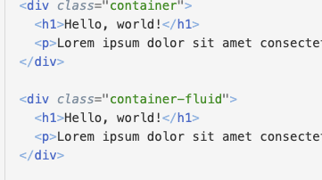
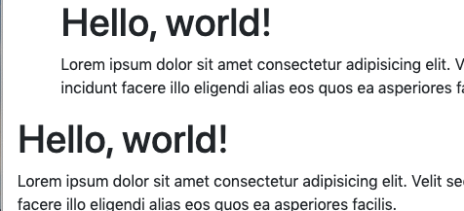

7 Grid
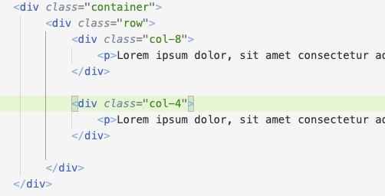

8 grid automático
No va el número de la columna

9 grid responsive
https://getbootstrap.com/docs/4.4/layout/overview/
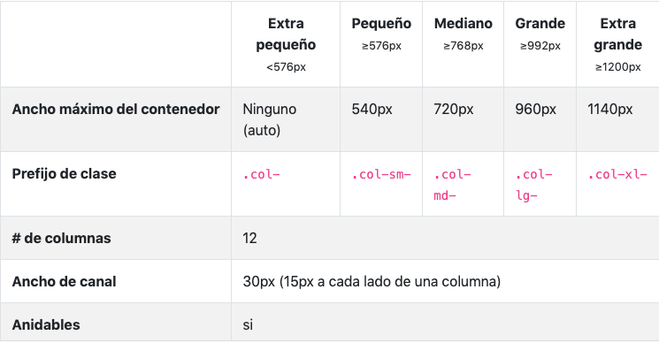
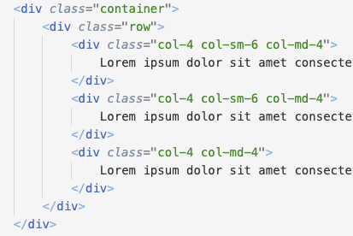

10 Alineamiento
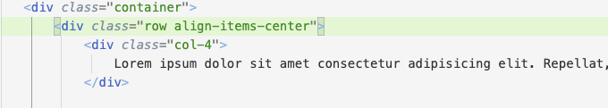
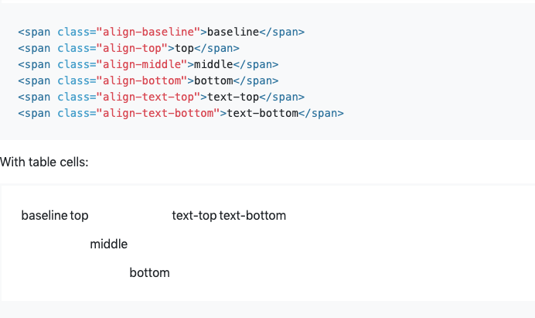
11 practica grid
grid-practica.html

12 no-gutters


13 tipografía
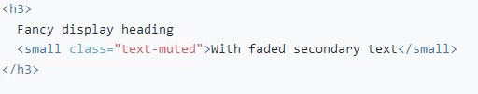


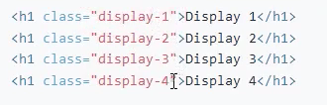

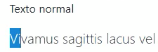
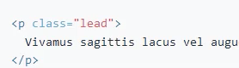

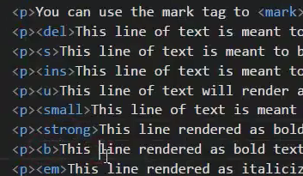
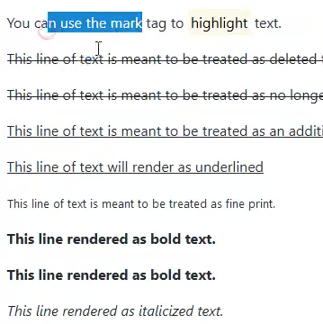

<p><abbr title="attribute">attr</abbr></p>
<p><abbr title="HyperText Markup Language" class="initialism">HTML</abbr></p>

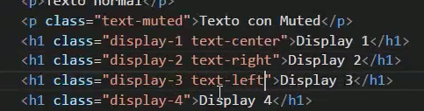

14 colores
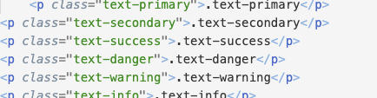
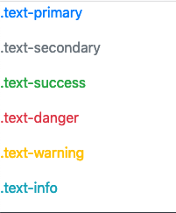

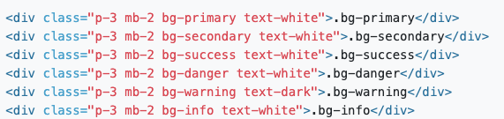

15 margenes y padding
5 es lo máximo
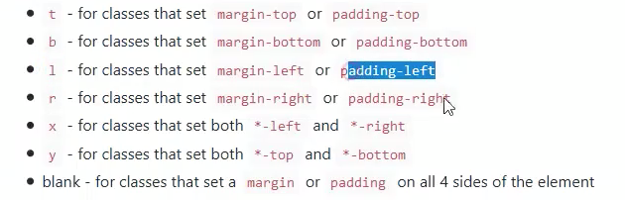

16 Práctica 2
<img src="imagenes/grafica.jpg" alt="..." class="img-fluid rounded">

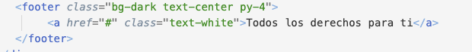

17 alertas
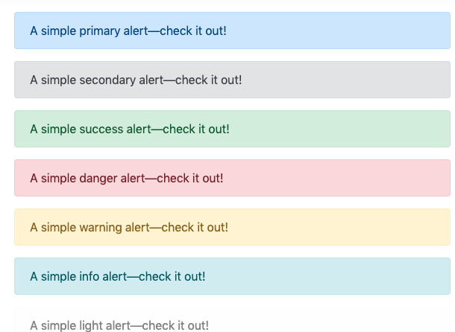

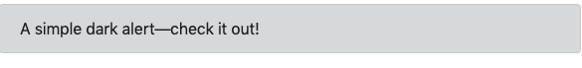

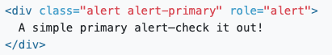

<div class="alert alert-primary" role="alert">
A simple primary alert with <a href="#" class="alert-link">an example link</a>. Give it a click if you like.
</div>

17 Badget Insignias
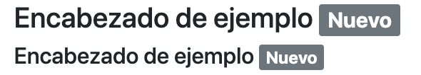

<div class="alert alert-primary" role="alert">
A simple primary alert with <a href="#" class="alert-link">an example link</a>. Give it a click if you like.
</div>

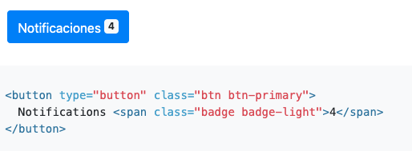

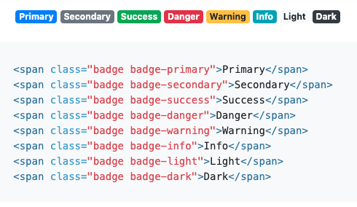

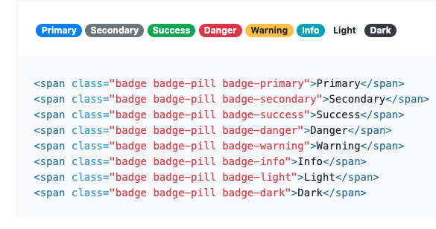

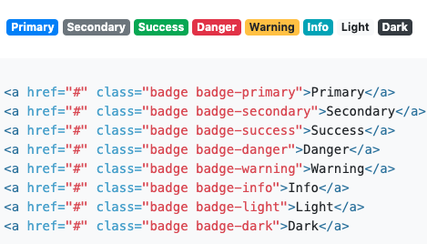

19 BreadCrumb
Indique la ubicación de la página actual dentro de una jerarquía de navegación que agrega separadores automáticamente mediante CSS.

<nav aria-label="breadcrumb">
<ol class="breadcrumb">
<li class="breadcrumb-item"><a href="#">Home</a></li>
<li class="breadcrumb-item"><a href="#">Library</a></li>
<li class="breadcrumb-item active" aria-current="page">Data</li>
</ol>
</nav>

20 boton

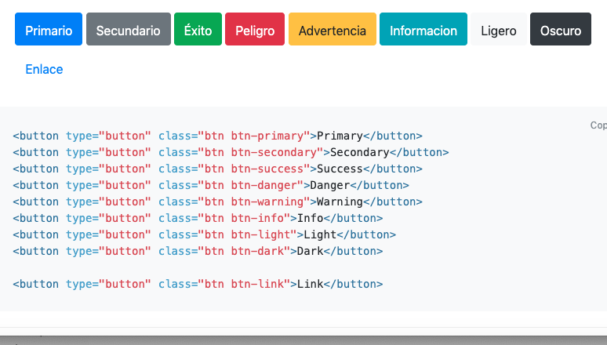

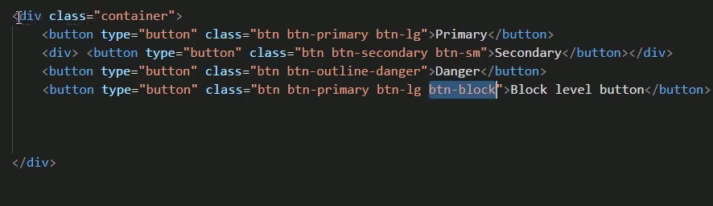
21 grupo de botones
<div class="btn-group" role="group" aria-label="Basic example">
<button type="button" class="btn btn-secondary">Left</button>
<button type="button" class="btn btn-secondary">Middle</button>
<button type="button" class="btn btn-secondary">Right</button>
</div>

<div class="input-group">
<div class="input-group-prepend">
<div class="input-group-text" id="btnGroupAddon">@</div>
</div>
<input type="text" class="form-control" placeholder="Input group example" aria-label="Input group example" aria-describedby="btnGroupAddon">
</div
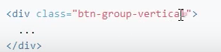

22 carrusel
23 collapse

26 dropdown
27 jumbotron
28 listas
29 modal
30 navBar

<div class="container-fluid bg-primary">
<nav class="navbar navbar-expand-md navbar-dark bg_primary container">
<a class="navbar-brand" href="#">Navbar</a>
<button class="navbar-toggler" type="button" data-toggle="collapse" data-target="#navbarSupportedContent" aria-controls="navbarSupportedContent" aria-expanded="false" aria-label="Toggle navigation">
<span class="navbar-toggler-icon"></span>
</button>
<div class="collapse navbar-collapse" id="navbarSupportedContent">
<ul class="navbar-nav ml-auto">
<li class="nav-item active">
<a class="nav-link" href="#">Home <span class="sr-only">(current)</span></a>
</li>
<li class="nav-item">
<a class="nav-link" href="#">Link</a>
</li>
<li class="nav-item dropdown">
<a class="nav-link dropdown-toggle" href="#" id="navbarDropdown" role="button" data-toggle="dropdown" aria-haspopup="true" aria-expanded="false">
Dropdown
</a>
<div class="dropdown-menu" aria-labelledby="navbarDropdown">
<a class="dropdown-item" href="#">Action</a>
<a class="dropdown-item" href="#">Another action</a>
<div class="dropdown-divider"></div>
<a class="dropdown-item" href="#">Something else here</a>
</div>
</li>
<li class="nav-item">
<a class="nav-link disabled" href="#" tabindex="-1" aria-disabled="true">Disabled</a>
</li>
</ul>
</div>
</nav>
</div>

31 brand

seccion 5 práctica 3

